**t -Retail**

**Digital Banking**

CONSOLIDATED DOCUMENT OF SIGN IN

**Agreement Tracking**

**Sonali Intellect Limited**

**, Bangladesh**



**COPYRIGHT NOTICE**

**Copyright © 2025, Sonali Intellect Limited**

**All rights reserved.**

These materials are confidential and proprietary to Sonali Intellect Limited and no part of these materials should be reproduced, published, transmitted or distributed in any form or by any means, electronic, mechanical, photocopying, recording or otherwise, or stored in any information storage or retrieval system of any nature nor should the materials be disclosed to third parties without the prior express written authorization of Sonali Intellect.

**Revision History**

|  |  |  |  |  |  |
| --- | --- | --- | --- | --- | --- |
| **Version** | **Published Date** | **Description of changes** | **Author** | **Reviewed By** | **Approved By** |
|  |  |  |  |  |  |
| 1.0.0 | 13-07-2025 |  | Rejoanul Islam Asif |  |  |

**­­­**

**­­**

**TABLE OF CONTENTS**

1. INTRODUCTION 4

1.1 Purpose of the Document 4

1.2 References 4

1.3 Terminology 4

1.3.1 Field Rule Properties 4

1.3.2 Field Type 5

1.3.3 Data Element 5

1.3.4 Acronyms & Abbreviations 5

2. PROJECT OVERVIEW 6

3. PREREQUISITES 6

4. BUSINSESS REQUIREMENT- SIGN IN 6

4.1 Sign In 6

4.1.1 User Journey 6

4.1.2 Authentication Flow……………………………………………………………………………………………………7

4.1.3 User Flow…..……………………………………………………………………………………………………………….8

5. USER INTERFACES 9

# INTRODUCTION

## Purpose of the Document

This document describes the sign-in functionality for the Agreement Tracking System implemented in Django (backend) and React (frontend). It covers authentication workflows, API endpoints, and UI specifications. The intended audiences for this document are:

The intended audiences for this document are:

1. Users
2. Testers
3. Technical Architects & Developers

## References

|  |  |
| --- | --- |
| **Document Name** | **Description** |
| API_ENDPOINTS_GUIDE.md | API specifications for React integration |

## Terminology

### Field Rule Properties

This section lists down field type and field rule description

|  |  |
| --- | --- |
| **Code** | **Description** |
| R | Required |
| O | Optional |
| C | Conditional |
| NA | Not applicable |

### Field Type

|  |  |
| --- | --- |
| **Code** | **Description** |
| CB | Checkbox |
| F | Free format input (typically in a text box / text area) |
| P | Password |

### Data Element

|  |  |  |  |  |  |
| --- | --- | --- | --- | --- | --- |
| **Data Type** | **Description** | **Allowed Characters** | | | |
| NUM/N (XX) | Number | 0 to 9 |  |  |  |
| AN | Alphanumeric | a to z | A to Z | 0 to 9 |  |
| A | Alphabet | a to z | A to Z |  |  |
| DAT | Date (DD/MM/YYYY) | 0 to 9 | - | / |  |

### Acronyms & Abbreviations

|  |  |  |
| --- | --- | --- |
| **S N** | **Term** | **Explanation** |
| 1 | API | Application Programming Interface |
| 2 | JWT | JSON Web Token |
| 3 | CORS | Cross-Origin Resource Sharing |
| 4 | POST | Power On Self Test |
| 5 | CSRF | Cross Site Request Forgery |

# PROJECT OVERVIEW

The Agreement Tracking System requires secure user authentication with the following features:

1. Email/password-based sign-in
2. Session management
3. CSRF protection
4. Role-based access control

# PREREQUISITES

Key elements and prerequisites for Login process:

1. Users must be registered in the system.
2. Valid email and password are required.
3. CSRF tokens must be handled for POST requests.

# BUSINSESS REQUIREMENT- SIGN IN

Users will be able to log in for Agreement Tracking by using following methods:

## Sign In

### User Journey

1. Overview

Users will be able to access the Agreement Tracking through the sign-in process, which includes authentication and session management.

2. Sign In Process

2.1 User Journey

a. Login Methods:

Customers can log in using the following method:

Web: Email and password.

b. Authentication:

Backend validates credentials via POST /api/accounts/login/.

c. Session Management:

Single session per user.

d. Session Expiry:

Session expires after 30 minutes of inactivity.

e. Error Handling - Incorrect Credentials:

If a user enters incorrect credentials:

The system will not allow access.

An error message will be displayed: Invalid credentials: 401 Unauthorized with error message

### Authentication Flow

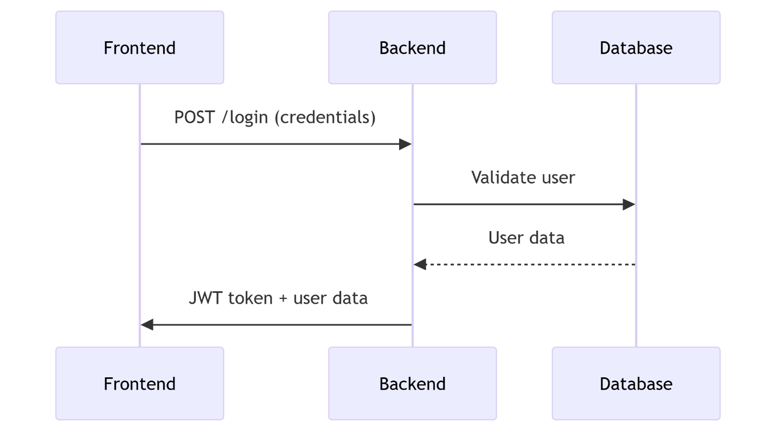

### User Flow

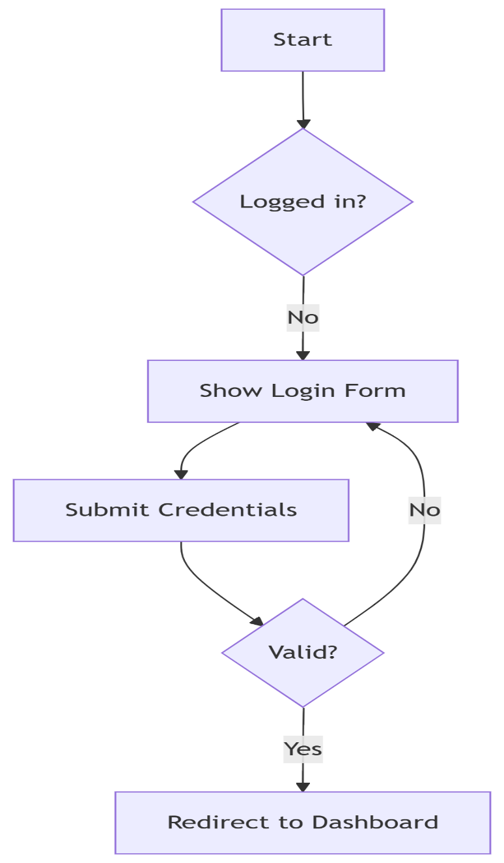

Note:

Web: Refers to accessing Agreement Tracking through a web browser.

This documentation outlines the steps involved in the sign-in process for Agreement Tracking, ensuring secure access and session management for customers.

# USER INTERFACES

**For Web:**

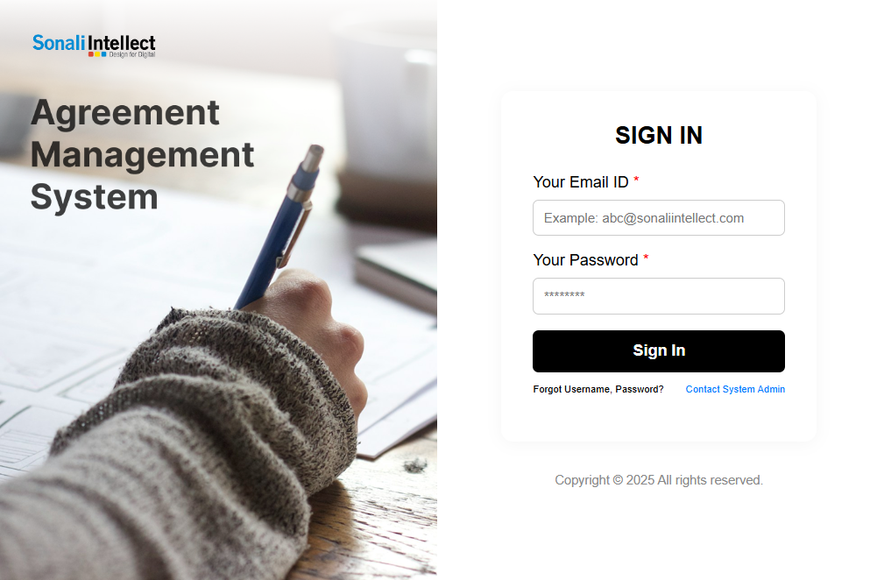

|  |  |  |  |  |  |
| --- | --- | --- | --- | --- | --- |
| **Field Name** | **Field Rule** | **Data Element** | **Touch Points** | **Configurable** | **Description** |
| Email | R | AN+ |  | Y | User’s registered email address. |
| Password | R | AN+ |  | Y | Password complying with policy. |

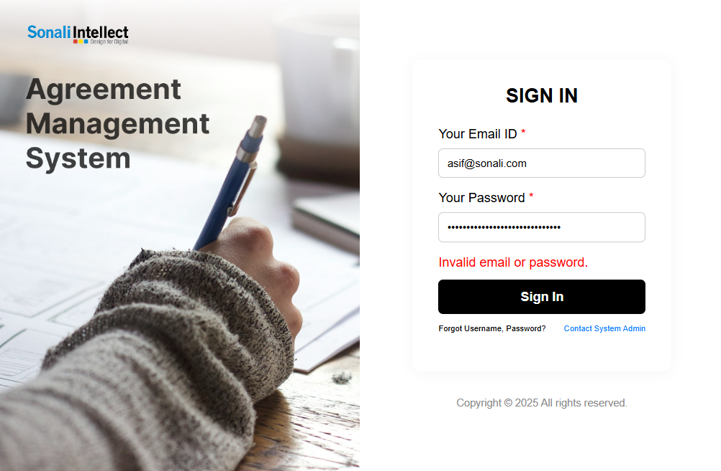

|  |  |  |  |  |  |
| --- | --- | --- | --- | --- | --- |
| **Field Name** | **Field Rule** | **Data Element** | **Touch Points** | **Configurable** | **Description** |
| Email | R | AN+ |  | Y | User will be able to view their entered email. |
| Password | R | AN+ |  | Y | User will be able to view their entered password |